Getting Started with Oracle SQL Developer

SQL Developer[1] is an integrated development environment for working with an Oracle database.

You can access it from the Start menu or simply search for SQL Developer

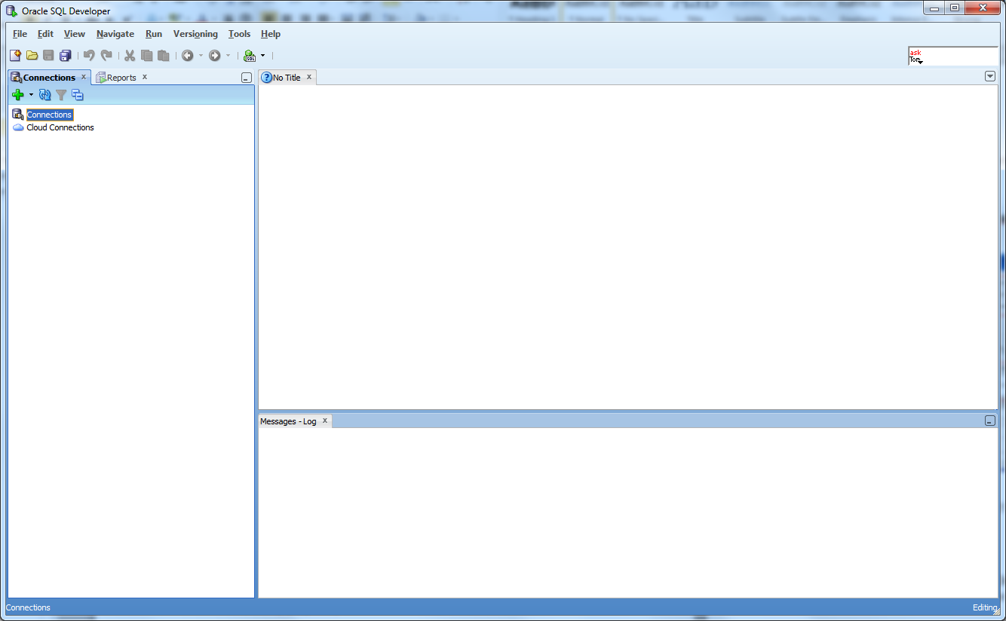

**Creating a connection**

To create a new connection, click the green Plus  in the Connections pane and enter the following:

A connection name

this can be (almost) anything but it should be meaningful, e.g. your <username> on <servername> , joeuser on larry

Your Oracle username

By default, your username is set up to be your full university email address[2] with the '@students.plymouth.ac.uk' and any other punctuation removed, e.g. 'joe.user@students.plymouth.ac.uk' has a user name of 'joeuser'.

Your Oracle password

Your default password is 'A' followed by your student registration number, e.g. 'A12345678'. Note that the correct case is important as your password is case sensitive.

For security purposes, do NOT check the Save Password box.

Host name[3]

This is the primary Oracle server – **larry.uopnet.plymouth.ac.uk**

Port

Oracle is configured to use server port **1521**

SID

The Oracle **S**ystem **ID**entifier – **ORCL** in this case

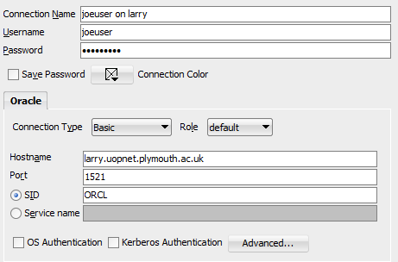

Click Connect (or Test first) to connect to the Oracle server and open an SQL Worksheet.

Enter a simple query - note that SQL Developer highlights reserved words - and click the Run button Run.JPG to run the statement.

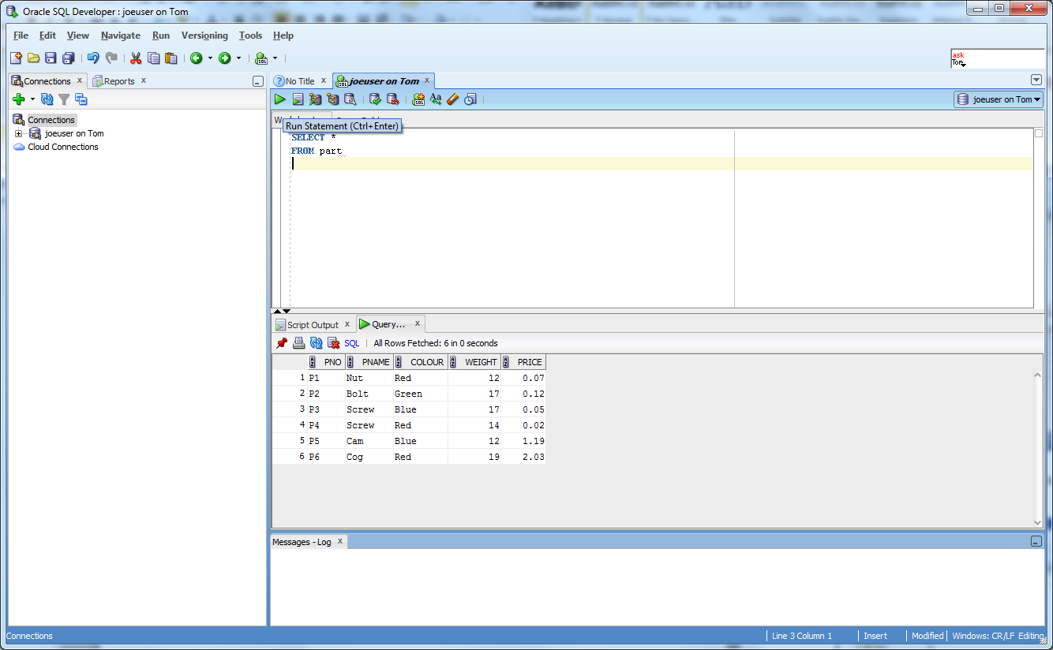

Alternatively, click the Run Script button Run Script.JPG to produce script output similar to SQL*Plus.

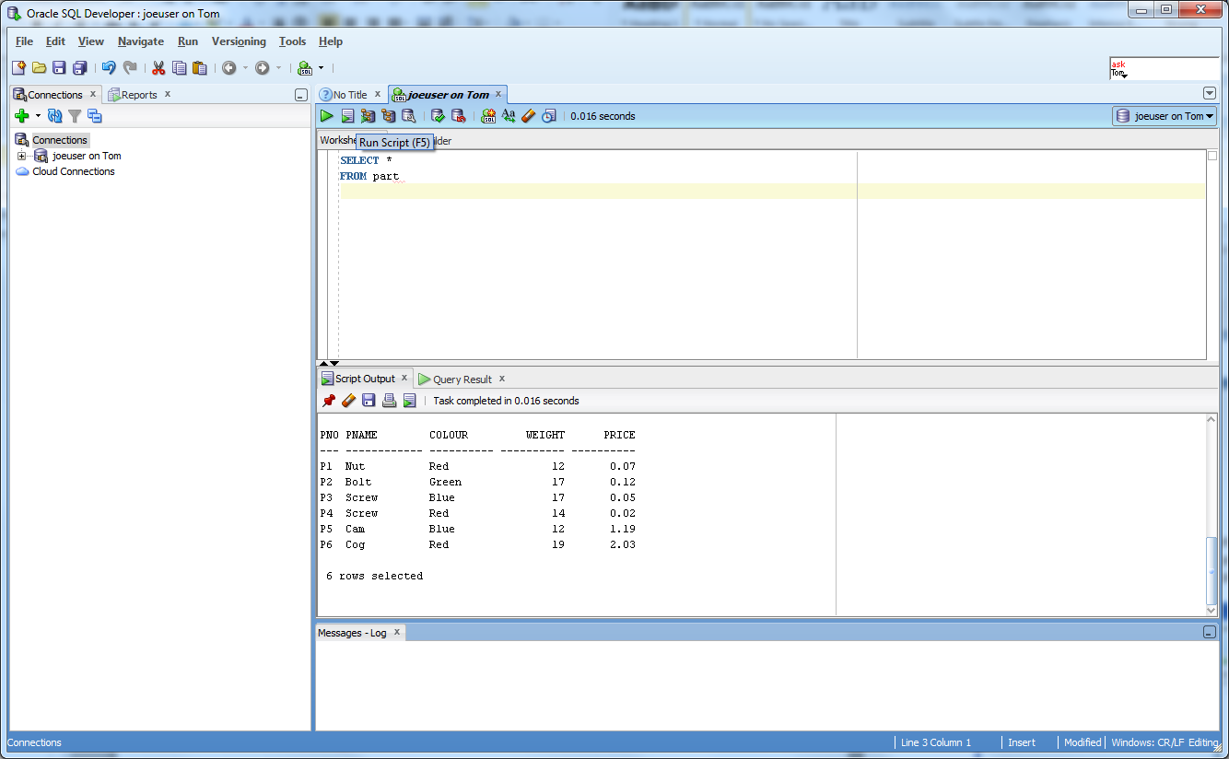

**Saving your connection**

Rather than have to remember all of your connection settings, you might find it easier to export your connection to your U drive (or DropBox, etc.). Right click on the connections node and select Export Connections.

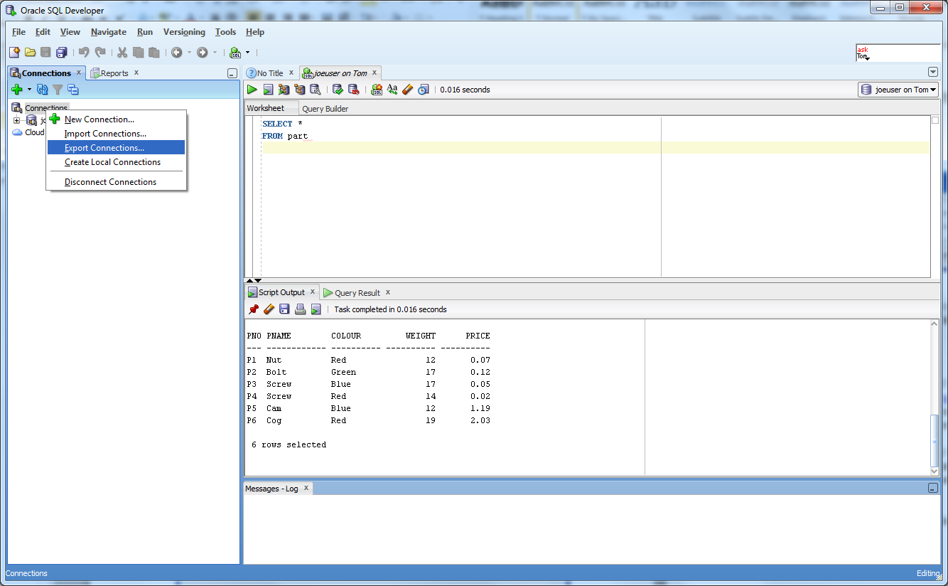

Navigate to your preferred storage location and save your connections as (say) my_oracle_connection.

## 

## When you start up SQL Developer again, simply right click on the Connections node and Import Connections from this file.

## Changing your password

Once you have logged in successfully for the first time, you should change your password for security purposes.

To do this simply type

password

click the Run button and follow the prompts

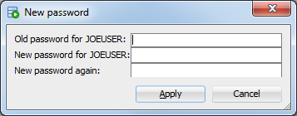

Disconnect your session (right click on your connection in the Connections pane) and re-connect to make sure that your password change has been applied.

## If you forget your password

If you forget your password, you need to contact your Oracle Database Administrator, Ismini Vasileiou ([ismini.vasileiou@plymouth.ac.uk](mailto:ismini.vasileiou@plymouth.ac.uk)), who will reset it for you as soon as possible. However, there may be some delay, so the best advice is not to forget it in the first place!!

Expand the Other Users node (right at the bottom of the hierarchy) in the Connections window and navigate to and expand the BRIAN node. You can see some of BRIAN’s tables, e.g., authors, books, publishers, sources, customers, orders and order_lines. These tables form the basis of the SQL Harrington Problem Sheet

Spend a few minutes running some sample queries and getting used to the interface.

1. <http://www.oracle.com/technetwork/developer-tools/sql-developer/overview/index.html>
2. You may find that you have a number appended to your email address, e.g. john.smith100. If so, this will form part of your username
3. You can also use the server's IP address - **141.163.170.213** or just **larry** on campus